E-event Management System

Abstract

E-EVENT MANAGEMENT SYSTEM

Overview: Now a day’s many people are celebrating their functions, birthdays, parties, meetings...etc well and grandly
No System is there which provides information about all these in details. So, a project titled E Event management System is planned to design . the main I am is to locate all the information which is single website. The event management System provides better information about any event description and location in a. p

Objectives:
To eliminate the time- wastage of customer.
Easly to accessible by customer.

Hard ware:
Ram:512MB or above
Hard disk: 60GB or above
Processor: Intel pentium4 or above

Soft ware:

Operating system: WindosXP or later
Languages: .net

Front end:

Microsoft visualStudio2008

Back end:

SQL Server 2005
ASP.Net
ADO.Net

INDEX

Contents

1. Introduction

2. Background
2.1 Theoretical Background
2.2 Technical Background

3. Analysis
3.1 problem definition
3.2 Proposed solution
3.3 Feasibility study
3.3.1 Operational Feasibility
3.3.2 Technical Feasibility
3.3.3 Economical Feasibility
3.3.4 Feasibility Report
3.4 Software Requirement Specification

4 Design
4.1 Unified Modeling Language
4.1.1 Use case Diagram
4.1.2 Sequence Diagram
4.1.3 Activity Diagram
4.1.4 Class Diagram
4.1.5 Deployment Diagram

5. Coding

6. Testing

7. Output Screens

8. Conclusion

9. Bibliography

INTRODUCTION
INTRODUCTION

Today entertainment and event management has become a large income generating market. Many of the industry profiles state that any event which requires funds would call for an excess budget, but the fact is a well planned strategy for an event will work on any budget. Event management thus becomes a very important part of your event plan.
Now a days many people are celebrating their functions ,birthday Parties,Meetings,…etc well and grandly.The main goal of this project is to provide interaction between Customer and Owner of particular event organization ,to provide better information to the customers with in short time.

It does mean big money, but it also involves lots of discipline and meticulous planning to be in this profession. So if you are think you are that type then go ahead and take the plunge. Planning an event is an event in itself. Your job as far as organising an even begins with the very basics. The client comes to the event manager with a vague idea in mind…it is entirely upto the event manager to work on the idea and turn it into a reality. Events could be anything from concerts, product launches, conferences, promotions, press conferences, jubilee celebrations and farewells to television based events, fashion shows, wedding or parties… it could be just anything.

BACKGROUND
BACKGROUND

2.1 THEORETICAL BACKGROUND:

Event management is a booming industry. Rising social and commercial activities have given rise to the business of event management. In metropolitan cities, social occasions and corporate events are arranged for as an extravaganza. Arrangement for social ceremonies like wedding and corporate events like product launch is a mammoth responsibility to shoulder. Only event management service can lift off this burden on your shoulder. Evenementen organisatie services fill the gap between you and the knowledge of how to organize an event. Being the owner of a top-notch corporate house, you should organize business events ensuring perfection of each and every detail. If an event is purposive, make a go of it through meticulous arrangement. An event planner with expertise and experience in this field can bring an event alive with difference. Note that successful event organization entails not only the knowledge of some practical aspects but also lots of creativity. Proper execution of an event requires an event planner to be excellent in cost planning, decoration art, cuisine, hospitality and aestheticism. Do not let events be a failure. You invest considerably on them. Seek the services of an evenement organisatiebureau to reap benefits from your investment. It saves you not only troubles of overall arrangement but also a lot of money. Wedding is a grand ceremony. Evidently, wedding arrangement requires consideration of several things like culinary service, entertainment, decoration, reception and adornment. Leave the entire job of wedding arrangement to a wedding planner and his subordinates. Feel free to interact with your invitees and guests. Wedding is not the only event to hire the services of a professional evenementen organisatie company for its impressive and immaculate arrangement. Marketability and profitability of a commercial establishment depends on the success of business events that are exclusively held to deal with offshore clients. Therefore, a cutting-edge planning is the first and foremost need for the successful organization of a business event. Annual staff parties for the appraisal of employees' performance or their entertainment are common at corporate hubs. An event organizer efficiently nurtures several responsibilities of personeelsfeesten like culinary arrangement and entertainment. Attending to your business partners and catering to their needs is the most important of all that needs your attention. You can be sure of satisfactory service to your clients only by employing the services of an evenementenbureau. Checking the accomplishments and achievements of an event organizer is a must do before you entrust the organizer with the responsibility of an event. All event planners are not similarly dexterous in the field of event management. Qualifications of an event manager are not enough to rely on him or her. His or her market experience is of immense importance to add value to your event. Event management is a multi-faced profession. So, be sure of the excellence of event organizing professionals in planning and budgeting, catering and communication.

Symphony has an excellent track record for providing easy to use online event management software that saves time, money and hassle. And now we’ve made it even better.

The next generation Symphony online event management software makes organising even the most complex conferences and events quick and easy. Plus, this innovative web-based software solution means you always have all the information you need, wherever you are.

Symphony offers you all this:

Excellent customer support

Every member of the team, from project managers to software developers live and breathe customer service. We are 100% committed to offering all our clients the very highest levels of support, and it shows. Just talk to us to find out.

Ease of use

By listening to what our clients want, we have created an intuitive, yet amazingly powerful range of online event management services that are refreshingly easy to use.

Extensive functionality

Symphony handles all the tasks you have to do, and more. With everything from online booking to email marketing of your event all taken care of, organising a successful event has never been easier.

Personalised training

Symphony is simple and intuitive to use. To help you get the most from this feature-rich software a range of training options are available to suit your needs and circumstances.

Ongoing development

The event world never stands still and neither do we. Our development team are always creating new and better tools to allow for greater control, autonomy and synchronisation with your system.

We come highly recommended

We help a wide range of businesses organize a hugely diverse array of events. Each one is different, but we’re proud to say they would all recommend Symphony.

Bespoke design and development

Symphony works for everyone, but you can make it work even harder for you with a range of bespoke design and development solutions. Just tell us what you need and we’ll do the rest.

Developer framework Web API

Empowering third-party developers to hook into Symphony represents a huge step forward in fully integrating this sophisticated online event management software with your system. And the Symphony Sandbox area even allows developers to experiment with the web API without the risk of breaking anything.

When you add it all up, it’s easy to see why more and more event organizers trust Symphony to help them get the job done quicker and easier.

2.2 TECHNICAL BACKGROUND:

INTRODUCTION TO .NET FRAMEWORK

.NET is a broad initiative meant to revolutionize the way applications are built. Architect with the Internet in mind, .NET is cross-platform and cross-language. It enables the creation of loosely coupled Web Services based on Internet standards like XML and SOAP. But with its universal runtime and Base Class Library, it also dramatically simplifies Windows development as well.

The .NET platform enables the creation and use of XML-based applications, processes, and Web sites as services that share and combine information and functionality with each other by design, on any platform or smart device, to provide tailored solutions for organizations and individual people.

The Operating Systems supported by .NET Framework are Windows 98, NT 4.0 SP6a, Windows 2000, or Me.

CORE .NET COMPONENTS:
From a technology standpoint, .NET is the platform and the .NET experiences built on top of the platform. The platform includes:

- Tools – to build applications and XML Web services ( .NET Framework and Visual Studio.NET),
- Servers – on which to build, host and deploy those applications and services (Windows 2000 Server and the .NET Enterprise Servers)
- Services – a core set of .NET building block services
- Client software – the software that powers smart devices, allowing users to interact and experience the .NET platform

THE .NET FRAMEWORK
The Framework is the most important piece for developers and provides the foundation for the other parts of .NET. The Framework is a layered architecture and is composed of multiple pieces. The .NET Framework provides a fully managed, protected, and feature-rich application execution environment, simplified development and deployment, and seamless integration with a wide variety of languages.

MAJOR COMPONENTS OF THE FRAMEWORK

- Common Language Runtime (CLR)
- Base Class Library
- Common Type System (CTS)
- Common Language Specification (CLS)

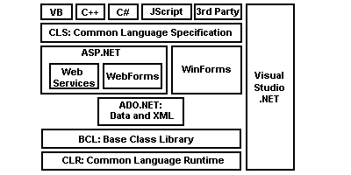

COMMON LANGUAGE RUNTIME (CLR)
The CLR is the heart and soul of .NET. The CLR is the runtime. In a nutshell, the CLR is a run-time environment in which .NET applications run. The Common Language Runtime (CLR) plays a role in both the development and execution of .NET applications. At runtime, the CLR is responsible for managing the execution environment of .NET (managed) code, including memory allocation and thread management, as well as enforcing security policies. Because the CLR automates these development tasks, development time is reduced and development tasks are simplified. For example, automated garbage collection means that you no longer have to worry about memory leaks.

Some of the key components of the CLR are shown in Figure

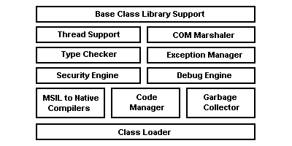

THE COMMON LANGUAGE RUNTIME (CLR)
The CLR provides the following benefits for application developers:

- Vastly simplified development
- Seamless integration of code written in various languages
- Evidence-based security with code identity
- Assembly-based deployment that eliminates DLL Hell
- Side-by-side versioning of reusable components
- Code reuse through implementation inheritance
- Automatic object lifetime management
- Self-describing objects

CLR

The CLR loads your code, manages it, runs it and provides a number of support services. Some of these vital support services include resource management; thread management, remoting, as well as enforcing code safety and security constraints. Code that is loaded and running under the control of the CLR is referred to as managed code. Compiled code in .NET does not contain assembly language instructions. Rather, code is compiled into assemblies that contain Microsoft Intermediate Language (MSIL). MSIL is a low level language, similar in idea to Java byte-code. The MSIL is NOT interpreted. It is JIT-compiled into native machine code.

The Following Listing shows the BCL

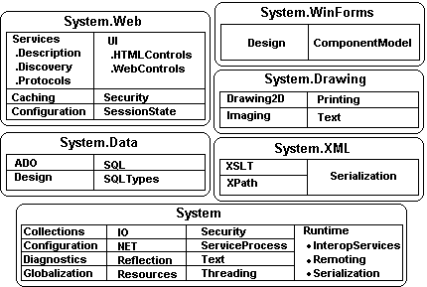

THE COMMON TYPE SYSTEM (CTS)
One of the reasons that the Common Language Runtime (CLR) is so powerful and universal is that it is based on the CTS. The CTS provides a very rich and standard set of data types. The CTS standards are the very thing that allows .NET to provide a unified programming model, and to support multiple languages. The CTS supports two general categories of types, each of which actually have a number of subcategories. The type of a reference type can be determined from values of self-describing types. Self-describing types are further split into arrays and class types. The class types are user-defined classes, boxed value types, and delegates.

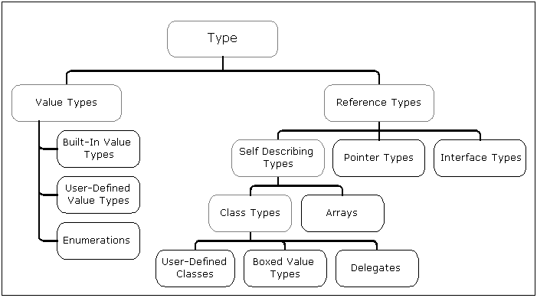

C#.NET :

Introduction to Window Forms (C#.NET)
Window Forms is the new platform for Microsoft Window application development, based on the .NET Framework. This framework provides a clear, object-oriented, extensible set of classes that enable you to develop rich Window applications. Additionally, Window Forms can act as the local user interface in a multi-tier distributed solution. Windows Forms is a framework for building Windows client applications that utilize the common language runtime. Window Forms applications can be written in any language that the common language runtime supports.
In Visual Studio.NET, building a Window Forms app is a lot like using Visual Basic: just drop a control onto a form then write an event handler. This article describes the Window Forms programming model, how it fits with ASP.NET, and introduces DataGrid, TextBox, and other classes in the .NET Framework class library.
As with all objects in the .NET Framework, forms are instances of classes. The form you create with the window Forms Designer is a class, and when you display an instance of the form at run time, this class is the template used to create the form. The framework also allows you to inherit from existing forms to add functionality or modify existing behavior. When you add a form to your project, you can choose whether it inherits from the Form class provided by the framework, or from a form you have previously created.
Additionally, forms are controls, because they inherit from the Control class.
Within a Window Forms project, the form is the primary vehicle for user interaction. By combining different sets of controls and writing code, you can elicit information from the user and respond to it, work with existing stores of data, and query and write back to the file system and registry on the user's local computer.
Although the form can be created entirely in the Code Editor, it is easier to use the Window Forms Designer to create and modify forms.

ADO.NET Overview
ADO.NET is an evolution of the ADO data access model that directly addresses user requirements for developing scalable applications. It was designed specifically for the web with scalability, statelessness, and XML in mind.
ADO.NET uses some ADO objects, such as the Connection and Command objects, and also introduces new objects. Key new ADO.NET objects include the DataSet, DataReader, and DataAdapter.
The important distinction between this evolved stage of ADO.NET and previous data architectures is that there exists an object -- the DataSet -- that is separate and distinct from any data stores. Because of that, the DataSet functions as a standalone entity. You can think of the DataSet as an always disconnected recordset that knows nothing about the source or destination of the data it contains. Inside a DataSet, much like in a database, there are tables, columns, relationships, constraints, views, and so forth.
A DataAdapter is the object that connects to the database to fill the DataSet. Then, it connects back to the database to update the data there, based on operations performed while the DataSet held the data. In the past, data processing has been primarily connection-based. Now, in an effort to make multi-tiered apps more efficient, data processing is turning to a message-based approach that revolves around chunks of information. At the center of this approach is the DataAdapter, which provides a bridge to retrieve and save data between a DataSet and its source data store. It accomplishes this by means of requests to the appropriate OLEDB commands made against the data store.
The XML-based DataSet object provides a consistent programming model that works with all models of data storage: flat, relational, and hierarchical. It does this by having no 'knowledge' of the source of its data, and by representing the data that it holds as collections and data types. No matter what the source of the data within the DataSet is, it is manipulated through the same set of standard APIs exposed through the DataSet and its subordinate objects.
While the DataSet has no knowledge of the source of its data, the managed provider has detailed and specific information. The role of the managed provider is to connect, fill, and persist the DataSet to and from data stores. The OLEDB and MSACCESS .NET Data Providers (System.Data.OleDb and System.Data.SqlClient) that are part of the .Net Framework provide four basic objects: the Command, Connection, DataReader and DataAdapter. In the remaining sections of this document, we'll walk through each part of the DataSet and the OLE DB/MSACCESS .NET Data Providers explaining what they are, and how to program against them.
When dealing with connections to a database, there are two different options: MSACCESS .NET Data Provider (System.Data.SqlClient) and OLE DB .NET Data Provider (System.Data.OleDb). In these samples we will use the MSACCESS .NET Data Provider. These are written to talk directly to Microsoft MSACCESS. The OLE DB .NET Data Provider is used to talk to any OLE DB provider (as it uses OLE DB underneath).

Connections
Connections are used to 'talk to' databases, and are respresented by provider-specific classes such as OLEDBConnection. Commands travel over connections and resultsets are returned in the form of streams which can be read by a DataReader object, or pushed into a DataSet object.
Commands
Commands contain the information that is submitted to a database, and are represented by provider-specific classes such as OLEDBCommand. A command can be a stored procedure call, an UPDATE statement, or a statement that returns results. You can also use input and output parameters, and return values as part of your command syntax. The example below shows how to issue an INSERT statement against the Northwind database.
DataReaders
The DataReader object is somewhat synonymous with a read-only/forward-only cursor over data. The DataReader API supports flat as well as hierarchical data. A DataReader object is returned after executing a command against a database. The format of the returned DataReader object is different from a recordset. For example, you might use the DataReader to show the results of a search list in a web page.
DataSets and DataAdapters
DataSets
The DataSet object is similar to the ADO Recordset object, but more powerful, and with one other important distinction: the DataSet is always disconnected. The DataSet object represents a cache of data, with database-like structures such as tables, columns, relationships, and constraints. However, though a DataSet can and does behave much like a database, it is important to remember that DataSet objects do not interact directly with databases, or other source data. This allows the developer to work with a programming model that is always consistent, regardless of where the source data resides. Data coming from a database, an XML file, from code, or user input can all be placed into DataSet objects..
The DataSet has many XML characteristics, including the ability to produce and consume XML data and XML schemas. XML schemas can be used to describe schemas interchanged via WebServices. In fact, a DataSet with a schema can actually be compiled for type safety and statement completion.
DataAdapters (OLEDB/SQL)
The DataAdapter object works as a bridge between the DataSet and the source data. Using the provider-specific OLEDBDataAdapter (along with its associated OLEDBCommand and OLEDBConnection) can increase overall performance when working with a Microsoft MSACCESS databases.
The DataAdapter object uses commands to update the data source after changes have been made to the DataSet. Using the Fill method of the DataAdapter calls the SELECT command; using the Update method calls the INSERT, UPDATE or DELETE command for each changed row. You can explicitly set these commands in order to control the statements used at runtime to resolve changes, including the use of stored procedures. For ad-hoc scenarios, a CommandBuilder object can generate these at run-time based upon a select statement. However, this run-time generation requires an extra round-trip to the server in order to gather required metadata, so explicitly providing the INSERT, UPDATE, and DELETE commands at design time will result in better run-time performance.

ANALYSIS
3. ANALYSIS
There are 5 important steps in the analysis. They are
- Identification of the customers/owners.
- Development a simple business process model.
- Developing the use cases.
- Developing the interaction diagrams.
- Classifications.
SOFTWARE METHODOLOGY:
Using JACOBSON METHDOLOGIES to develop the proposed system.

INTRODUCTION:
In 1986 BOOCH developed the Object Oriented Design concept is called as BOOTCH METHOD. It covers both analysis and Design phases of the Object Oriented System, The BOOTCH METHOD consists o following diagrams:

- Class diagrams
- Object diagrams
- State transition diagram
- Module diagram
- Process diagram
- Interaction diagram

BOOTCH used the large set of symbols. Even though BOOTCH defines a lot of symbols to document almost every design decision, if we work with his method, you will notice that you never use all these symbols and diagrams; This is this main draw back of the BOOTCH METHOD.

In 1991 Jim Raumbaugh develop the OMT (Object Modeling Technique) with the help of his team It covers analysis, Design and implementation of the system.

OMT separates Modeling into three different parts:

- Object Model

Presented by the Object Model and the data dictionary.

- Dynamic model
Presented by the State diagrams and Event flow diagrams.

- Functional Model

Presented by Data flow and constraints.

There is no traceability in the different phases, both forward and back ward; this is the main disadvantage of the OMT.

In order to avoid the problems faced in the above two models JACOBSON invented the one model called as the JACOBSON METHDOLOGIES (Object Oriented Software Engineering). It will cover the entire life cycle and stress tractability between different phases, 0both forward and back ward, Additionally he invented the Use case diagrams, these diagrams are necessary to understanding system requirement. It captures the goal of the system. It is used to identify the Use cases and External users (external users are the users who interact with our system to complete the task)

THE JACOBSON ET AL. METHDOLOGIES:

JACOBSON METHDOLOGIES (Object Oriented Software Engineering) OOSE cover the Entire life cycle and stress trace ability between the different phases, both forward and backward. And Use case diagrams, these diagrams are necessary to understanding system requirement. It captures the goal of the system. It is used to identify the USE CASES and External users (external users are the users who interact with our system to complete the task)

The Use case Description must contain

- HOW and WHEN the use case begins and ends.

- The interaction between the use case and its actors, including WHEN the interaction occurs and WHAT is exchanged.

- HOW and WHEN the use case will need data stored in the system or will store data in the system.

- EXCEPTION TO THE flow of events.

- HOW and WHEN concepts of the problem domain are handled.

By using the use case model we will find the External users, External users are the users who will interact with our system to complete the task. Every single use case should describe one main flow of events. An exceptional additional flow of events could be added.

OBJECT ORIENTED SOFTEWARE ENGINEERING

Object oriented software engineering also called, as the objectory. It is build around several models:

  - USE CASE MODEL: The use-case model defines the outside (actor) and inside (use case) of the systems behavior.

  - DOMAIN OBJECT MODEL: The objects of the “real” world are mapped in to the main object model.

  - ANALYSS OBJECT MODEL: The analysis object model presents how the source code (implementation) is carried out and written.

  - IMPLIMENTATON MODEL: The implementation model represents the implementation of the system.

  - TEST MODEL: The test model constitutes the test plan, specification and reports.

JACOBSON METHDOLOGY consists following diagrams:

- Use case Diagrams
- UML activity diagram
- UML use Case Diagram
- Sequence diagrams
- Class diagrams
- Business class diagrams

USE CASE DIAGRAMS:

A use case describes a sequence of actions that provide something of measurable value to an actor and is drawn as a horizontal ellipse An actor is a person, organization, or external system that plays a role in one or more interactions with your system.
UML ACTIVITY DIAGRAM:

Activity diagrams are used to document workflows in a system, from the business level down to the operational level. When looking at an Activity diagram, you'll notice elements from state diagram, the Activity diagram is a variation of the state diagram where the "states" represent operations, and the transitions represent the activities that happen when the operation is complete. The general purpose of Activity diagrams is to focus on flows driven by internal processing vs. external events.

SEQUENCE DIAGRAMS:

UML sequence diagrams model the flow of logic within your system in a visual manner, enabling you both to document and validate your logic, and are commonly used for both analysis and design purposes. Sequence diagrams are the most popular UML artifacts for dynamic modeling, which focuses on identifying the behavior within your system.

Class diagrams:

A class diagram describes the static structure of the symbols in your new system. It is a graphic presentation of the static view that shows a collection of declarative (static) model elements, such as classes, types, and their contents and relationships. Classes are arranged in hierarchies sharing common structure and behavior, and are associated with other classes

Use Case Diagrams:
Its purpose is to define Piece of behavior. It describes both inside (use case) and outside (actor)
Behavior of the system. It describes what a system does.
These diagrams consist of:
- Use cases
- Actors
A use case is the specification of sequences of actions, including variant sequences and error sequences, which a system, subsystem or a class can perform by interacting with outside actors.
An actor may be any thing that interact with the system, human, hardware device or another system etc.

SOFTWARE REQUIRMENTS:

- FRONT END : ASP.NET.
- BACK END : MICROSOFT SQL SERVER 2005.
- OPERATING SYSTEM : Windows XP-2 (OR) WINDOWS 7.
- OTHER : ER-WIN TOOL, EDRAW MAX5.

3.4.2 HARDWARE REQUIREMENTS:

- PROCESSOR :Intel Pentium-4 or More
- HARD DISK : 80GB or More.
- RAM : 1GB or More.
- We can add any other Hardware according to our requirements.

4.DESIGN

The most creative and challenging phase of the life cycle is system design. The term design describes a final system and the process by which it is developed. It refers to the technical specifications that will be applied in implementations of the candidate system. The design may be defined as “the process of applying various techniques and principles for the purpose of defining a device, a process or a system with sufficient details to permit its physical realization”.

The designer’s goal is how the output is to be produced and in what format. Samples of the output and input are also presented. Second input data and database files have to be designed to meet the requirements of the proposed output. The processing phases are handled through the program Construction and Testing. Finally, details related to justification of the system and an estimate of the impact of the candidate system on the user and the organization are documented and evaluated by management as a step toward implementation.

The importance of software design can be stated in a single word “Quality”. Design provides us with representations of software that can be assessed for quality. Design is the only way where we can accurately translate a customer’s requirements into a complete software product or system. Without design we risk building an unstable system, that might fail if small changes are made. It may as well be difficult to test, or could be one who’s

Quality can’t be tested. So it is an essential phase in the development of a software product.

DATABASE DESIGN:
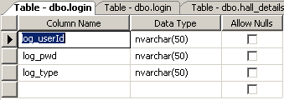

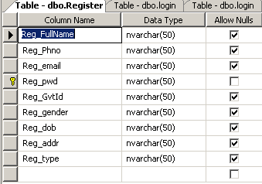

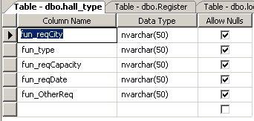

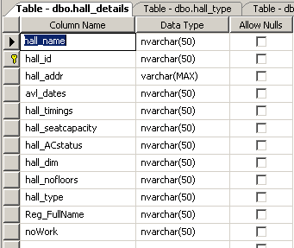

4.2 DATA FLOW DIAGRAMS:

A data flow diagram is graphical tool used to describe and analyze movement of data through a system. These are the central tool and the basis from which the other components are developed. The transformation of data from input to output, through processed, may be described logically and independently of physical components associated with the system. These are known as the logical data flow diagrams. The physical data flow diagrams show the actual implements and movement of data between people, departments and workstations. A full description of a system actually consists of a set of data flow diagrams. Using two familiar notations Yourdon, Gane and Sarson notation develops the data flow diagrams. Each component in a DFD is labeled with a descriptive name. Process is further identified with a number that will be used for identification purpose. The development of DFD’s is done in several levels. Each process in lower level diagrams can be broken down into a more detailed DFD in the next level. The lop-level diagram is often called context diagram. It consists a single process bit, which plays vital role in studying the current system. The process in the context level diagram is exploded into other process at the first level DFD.

The idea behind the explosion of a process into more process is that understanding at one level of detail is exploded into greater detail at the next level. This is done until further explosion is necessary and an adequate amount of detail is described for analyst to understand the process.

Larry Constantine first developed the DFD as a way of expressing system requirements in a graphical from, this lead to the modular design.

A DFD is also known as a “bubble Chart” has the purpose of clarifying system requirements and identifying major transformations that will become programs in system design. So it is the starting point of the design to the lowest level of detail. A DFD consists of a series of bubbles joined by data flows in the system.

DFD SYMBOLS:

In the DFD, there are four symbols

- A square defines a source(originator) or destination of system data
- An arrow identifies data flow. It is the pipeline through which the information flows
- A circle or a bubble represents a process that transforms incoming data flow into outgoing data flows.
- An open rectangle is a data store, data at rest or a temporary repository of data

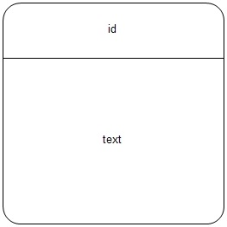
or
Process that transforms data flow.

Source or Destination of data
Data flow

Data Store

CONSTRUCTING A DFD:

Several rules of thumb are used in drawing DFD’s:

- Process should be named and numbered for an easy reference. Each name should be representative of the process.

- The direction of flow is from top to bottom and from left to right. Data traditionally flow from source to the destination although they may flow back to the source. One way to indicate this is to draw long flow line back to a source. An alternative way is to repeat the source symbol as a destination. Since it is used more than once in the DFD it is marked with a short diagonal.
- When a process is exploded into lower level details, they are numbered.
- The names of data stores and destinations are written in capital letters. Process and dataflow names have the first letter of each work capitalized

A DFD typically shows the minimum contents of data store. Each data store should contain all the data elements that flow in and out.

Questionnaires should contain all the data elements that flow in and out. Missing interfaces redundancies and like is then accounted for often through interviews.

SAILENT FEATURES OF DFD’s

- The DFD shows flow of data, not of control loops and decision are controlled considerations do not appear on a DFD.

- The DFD does not indicate the time factor involved in any process whether the dataflow take place daily, weekly, monthly or yearly.
- The sequence of events is not brought out on the DFD.

TYPES OF DATA FLOW DIAGRAMS
- Current Physical
- Current Logical
- New Logical
- New Physical

CURRENT PHYSICAL:

In Current Physical DFD process label include the name of people or their positions or the names of computer systems that might provide some of the overall system-processing label includes an identification of the technology used to process the data. Similarly data flows and data stores are often labels with the names of the actual physical media on which data are stored such as file folders, computer files, business forms or computer tapes.

CURRENT LOGICAL:

The physical aspects at the system are removed as mush as possible so that the current system is reduced to its essence to the data and the processors that transforms them regardless of actual physical form.

NEW LOGICAL:

This is exactly like a current logical model if the user were completely happy with he user were completely happy with the functionality of the current system but had problems with how it was implemented typically through the new logical model will differ from current logical model while having additional functions, absolute function removal and inefficient flows recognized.
NEW PHYSICAL:

The new physical represents only the physical implementation of the new system.

RULES GOVERNING THE DFD’S

PROCESS

- No process can have only outputs.
- No process can have only inputs. If an object has only inputs than it must be a sink.
- A process has a verb phrase label.

DATA STORE

- Data cannot move directly from one data store to another data store, a process must move data.
- Data cannot move directly from an outside source to a data store, a process, which receives, must move data from the source and place the data into data store
- A data store has a noun phrase label.

SOURCE OR SINK

The origin and /or destination of data.

- Data cannot move directly from a source to sink it must be moved by a process
- A source and /or sink has a noun phrase land

DATA FLOW:
- A Data Flow has only one direction of flow between symbols. It may flow in both directions between a process and a data store to show a read before an update. The later is usually indicated however by two separate arrows since these happen at different type.
- A join in DFD means that exactly the same data comes from any of two or more different processes data store or sink to a common location.
- A data flow cannot go directly back to the same process it leads. There must be at least one other process that handles the data flow produce some other data flow returns the original data into the beginning process.
- A Data flow to a data store means update (delete or change).
- A data Flow from a data store means retrieve or use.
A data flow has a noun phrase label more than one data flow noun phrase can appear on a single arrow as long as all of the flows on the same arrow move together as one package.

4.2.1 CONTEXT LEVEL:

The top-level diagram is often called a “context diagram”. It contains a single process, but it plays a very important role in studying the current system. The context diagram defines the system that will be studied in the sense that it determines the boundaries. Anything that is not inside the process identified in the context diagram will not be part of the system study. It represents the entire software element as a single bubble with input and output data indicated by incoming and outgoing arrows respectively.

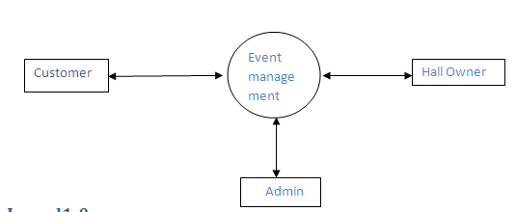

4.2.2 ZERO LEVEL:

Structured analysis states that the current system should be first understand correctly. The Zero Level DFD is the model of the current system and is used to ensure that the current system has been clearly understood. Zero Level DFDs shows actual devices, departments, people etc., involved in the current system

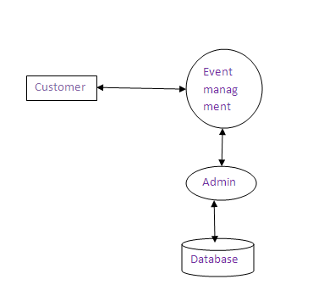

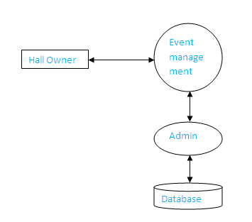

Level 1:

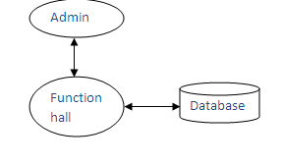

Level 1.1:

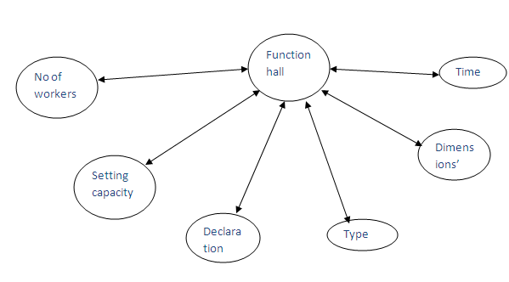

4.3UML DIAGRAMS:

The UML language is for

- Visualizing
- Specifying
- Construction
- Documenting

A CONCEPTUAL MODEL OF THE UML:

The three major elements of UML are

- The UML’s basic building blocks.
- Some common mechanisms that apply throughout the UML.

BASIC BUILDING BLOCKS OF THE UML

The vocabulary of UML encompasses three kinds of building blocks:
- Things
- Relationships
- Diagrams

Thing are the abstractions that are first-class citizens in a model.
Relationships tie these things together.
Diagrams group the interesting collection of things.

THINGS IN UML:

There are four kinds of things in the UML.
- Structural things.
- Behavioral things
- Grouping things
- Annotational things

OBJECT DIAGRAMS

Shows set of objects and their relationships. These are static snap shots of instances of the things found in the class diagram.

COMPONENT DIAGRAMS
Shows set of components and their relationships.

DEPLOYMENT DIAGRAMS
Shows a set of nodes and their relationships

COLLABORATION DIAGRAMS
Focuses on the structural organization of objects that send
and received messages.

CLASS DIAGRAMS ARE USED

During requirements analysis to model problem domain concepts,
During system design to model subsystems and interfaces,
During object design to model classes.
4.3.1 CLASS DIAGRAM:

A class diagram describes the static structure of the symbols in your new system. It is a graphic presentation of the static view that shows a collection of declarative (static) model elements, such as classes, types, and their contents and relationships.

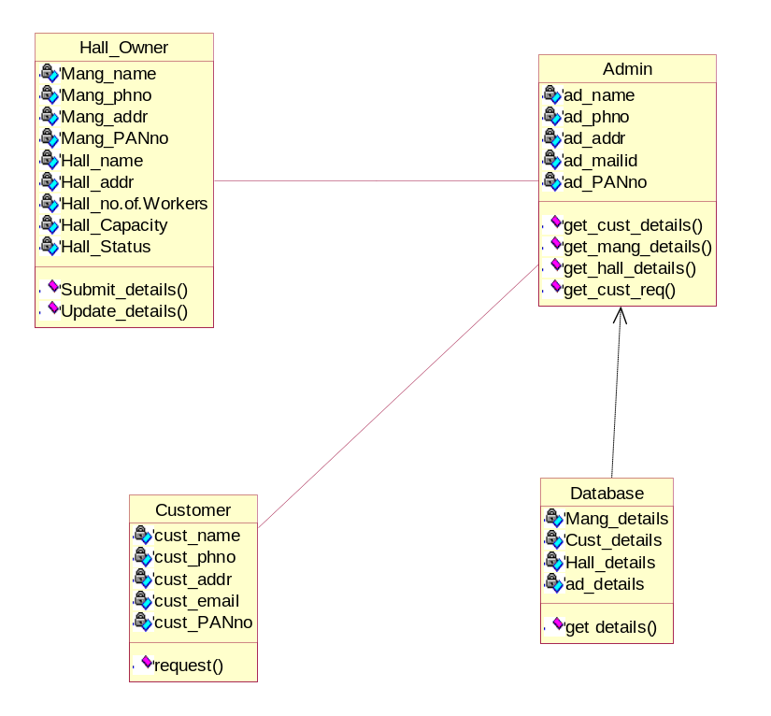

4.3.2USECASE DIAGRAM:

A use case describes a sequence of actions that provide something of measurable value to an actor and is drawn as a horizontal ellipse An actor is a person, organization, or external system that plays a role in one or more interactions with your system

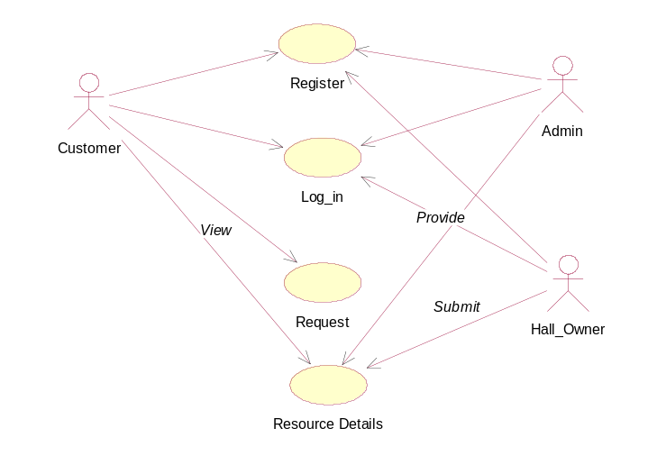
customer
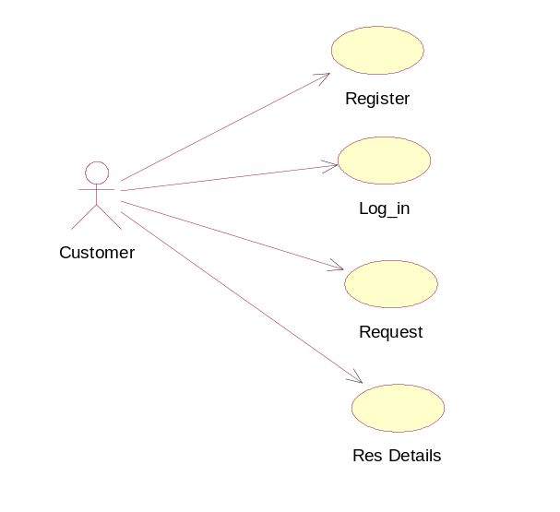

Hall Owner

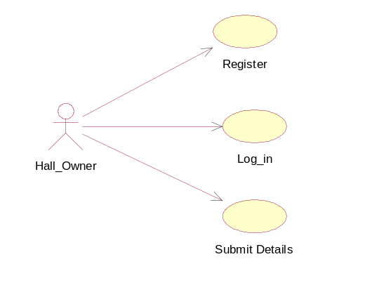

Admin
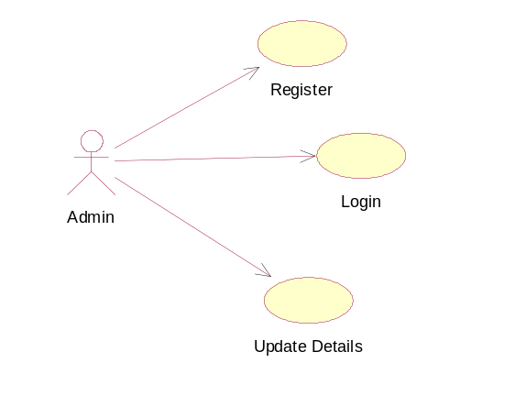

4.3.3SEQUENCE DIAGRAM:

UML sequence diagrams model the flow of logic within your system in a visual manner, enabling you both to document and validate your logic, and are commonly used for both analysis and design purposes. Sequence diagrams are the most popular UML artifacts for dynamic modeling, which focuses on identifying the behavior within your system.

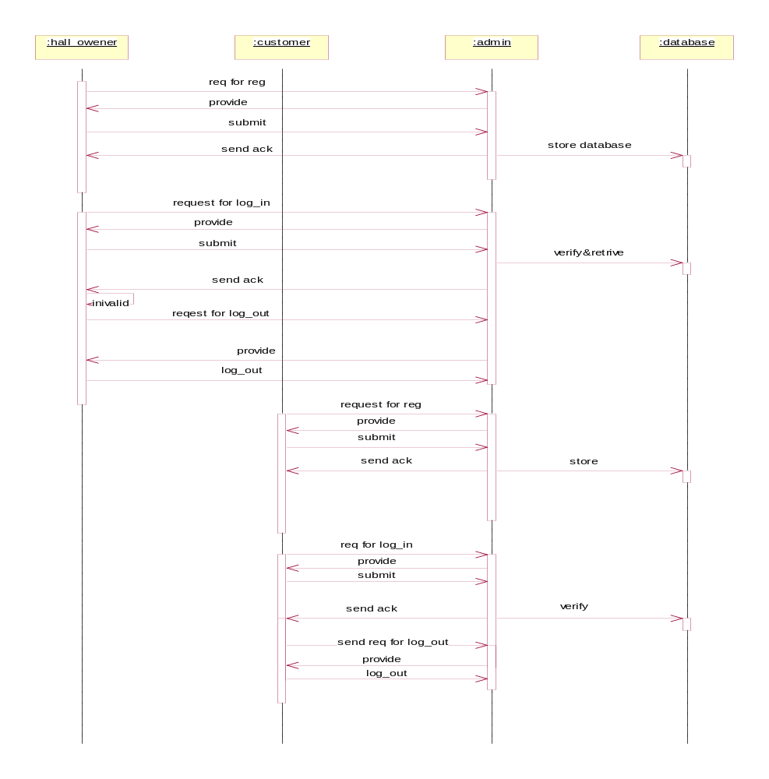

4.3.4 ACTIVITY DIAGRAM:

Activity diagrams are used to document workflows in a system, from the business level down to the operational level. When looking at an Activity diagram, you'll notice elements from state diagram, the Activity diagram is a variation of the state diagram where the "states" represent operations, and the transitions represent the activities that happen when the operation is complete. The general purpose of Activity diagrams is to focus on flows driven by internal processing vs. external events

Register
No
Please register newly nnntytytynew

yes
Login

Send Request

Log out

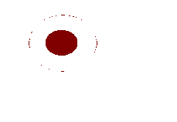

4.3.5 DEPLOYMENT DIAGRAM:

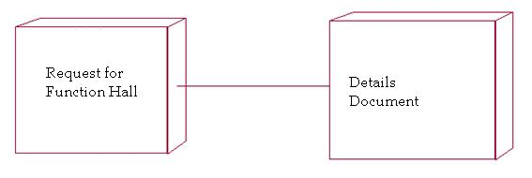

5.CODING
using System;
using System.Collections;
using System.Configuration;
using System.Data;
using System.Linq;
using System.Web;
using System.Web.Security;
using System.Web.UI;
using System.Web.UI.HtmlControls;
using System.Web.UI.WebControls;
using System.Web.UI.WebControls.WebParts;
using System.Xml.Linq;
using System.Data.SqlClient;

public partial class _Default : System.Web.UI.Page
{
protected void Page_Load(object sender, EventArgs e)
{

}
dbClass cls = new dbClass();
protected void Button1_Click(object sender, EventArgs e)
{
if (DropDownList1.SelectedItem.ToString() == "Customer")
{
DataSet ds = new DataSet();
ds = cls.select("select * from Register where Reg_FullName='" + TextBox1.Text + "' and Reg_pwd='" + TextBox2.Text + "'");
if (ds.Tables[0].Rows.Count == 1)
{
Response.Redirect("Userhome.aspx");
}
else
{
Response.Redirect("invalid user.....");
}
}
else if(DropDownList1.SelectedItem.ToString() == "Owner")
{
DataSet ds = new DataSet();
ds = cls.select("select * from login where log_userId='" + TextBox1.Text + "' and log_pwd='" + TextBox2.Text + "'");
if (ds.Tables[0].Rows.Count == 1)
{
Response.Redirect("OwnerHome.aspx");
}
else
{
Response.Redirect("invalid user.....");
}
}
else if (DropDownList1.SelectedItem.ToString() == "Admin")
{
if (TextBox1.Text == "Admin" && TextBox2.Text=="Admin")
{
Response.Redirect("AdminHme.aspx");
}
else
{
Response.Redirect("invalid user.....");
}
}

}

protected void LinkButton1_Click(object sender, EventArgs e)
{
Response.Redirect("Register.aspx");
}
}

Registration:
public partial class _Default : System.Web.UI.Page
{

protected void Page_Load(object sender, EventArgs e)
{

}
dbClass cls = new dbClass();

protected void Button1_Click(object sender, EventArgs e)
{
cls.insertdelupdate("insert into Register values('"+TextBox3.Text+"','"+TextBox4.Text+"','"+TextBox5.Text+"','"+TextBox7.Text+"','"+TextBox12.Text+"','"+DropDownList1.Text+"','"+TextBox9.Text+"','"+TextBox11.Text+"','"+DropDownList2.Text+"')");
Response.Write("registered successfully....");
}
}

Hall_Type:
public partial class Default2 : System.Web.UI.Page
{
dbClass cls = new dbClass();
protected void Button1_Click(object sender, EventArgs e)
{
cls.insertdelupdate("insert into hall_type values('"+DropDownList1.SelectedItem.ToString()+"','"+DropDownList2.SelectedItem.ToString()+"','"+TextBox1.Text+"','"+TextBox3.Text+"','"+TextBox2.Text+"')");
Response.Write("Request Inserted....!");
}
}

Hall_Details:
public partial class _Default : System.Web.UI.Page
{
protected void Page_Load(object sender, EventArgs e)
{
DataSet ds = new DataSet();
ds = cls.select("select Reg_FullName from Register where Reg_type='Owener'");
for (int i = 0; i < ds.Tables[0].Rows.Count; i++)
{
DropDownList1.Items.Add(ds.Tables[0].Rows[i].ItemArray[0].ToString());
}
}
dbClass cls = new dbClass();
protected void Button1_Click(object sender, EventArgs e)
{
cls.insertdelupdate("insert into hall_details values('" + TextBox1.Text + "','" + TextBox2.Text + "','" + TextBox10.Text + "','" + TextBox9.Text + "','" + TextBox5.Text + "','" + TextBox6.Text + "','" + DropDownList4.SelectedItem.ToString()+ "','" + DropDownList1.SelectedItem.ToString() + "','" + TextBox11.Text + "','" + DropDownList3.SelectedItem.ToString() + "','" + DropDownList5.SelectedItem.ToString() + "','" + TextBox8.Text + "')");
Response.Write("Inserted successfully.......");
}
}

public partial class _Default : System.Web.UI.Page
{
dbClass cls = new dbClass();
protected void Page_Load(object sender, EventArgs e)
{
DataSet ds = new DataSet();
ds = cls.select("select * from hall_details");
GridView2.DataSource = ds.Tables[0];
GridView2.DataBind();
}
}

public partial class AdminHome1 : System.Web.UI.MasterPage
{
protected void Page_Load(object sender, EventArgs e)
{

}
protected void Button5_Click(object sender, EventArgs e)
{
Response.Redirect("AdmincustReq.aspx");
}
protected void Button1_Click(object sender, EventArgs e)
{
Response.Redirect("AdminHome.aspx");
}
protected void Button2_Click(object sender, EventArgs e)
{
Response.Redirect("hall_details.aspx");
}
protected void Button3_Click(object sender, EventArgs e)
{
Response.Redirect("hall_type.aspx");
}
protected void Button4_Click(object sender, EventArgs e)
{
Response.Redirect("AdminCustview.aspx");
}
protected void Button6_Click(object sender, EventArgs e)
{
Response.Redirect("login.aspx");
}
protected void Button7_Click(object sender, EventArgs e)
{
Response.Redirect("AdminHallview.aspx");
}
}

6. TESTING

TESTING PRINCIPALS:

- All tests should be traceable to customer requirements
- .Tests should be planned long before testing begins.
- testing should begins “in the small” and progress toward testing “in the large”
- Exhaustive testing is not possible
- To be most effective, an independent third party should conduct testing

UNIT TESTING:
The first level of testing is called as unit testing. Here different modules are tested against the specifications produced during the design of the modules. Unit testing is done to test the working of individual modules with test Sql servers. Unit testing focuses verification effort on the smallest unit of software design that is the module. Using procedural design description as a guide, important control paths are tested to uncover errors within the boundaries of the module. The unit test is normally white box testing oriented and the step can be conducted in parallel for multiple modules.

In this project unit testing is performed in the following manner, For example if the data entered is correct then when the admin click on the save button, a message is shown as “record entered successfully”.

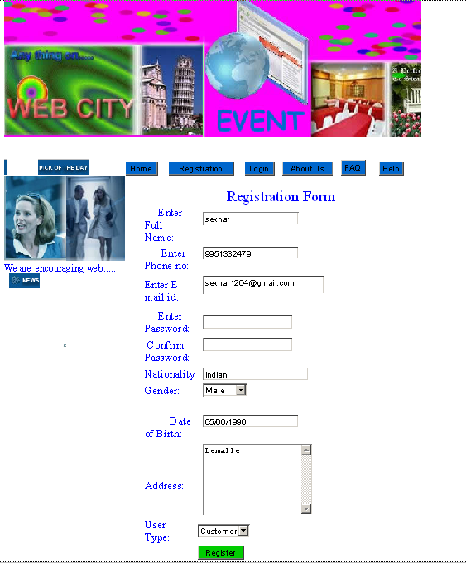

INTEGRATION TESTING:

Integration testing ensures that software and subsystems work together as a whole. It tests the interface ofall the modules to make sure that the modules behave properly when integrated together.
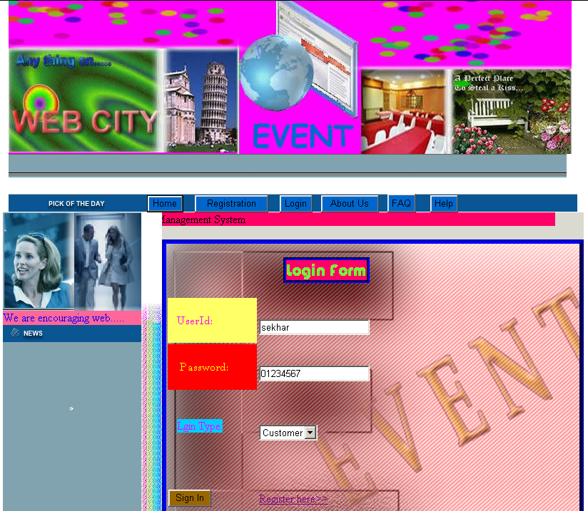

In this project the integration testing is performed for the login page and the home page together.When the Admin enter’s the correct user id and password then the home is opened.

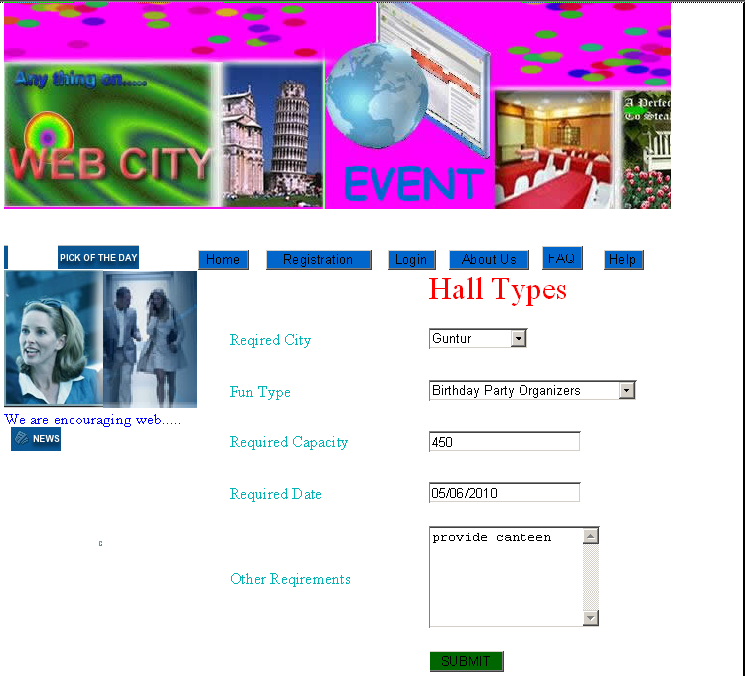

SYSTEM TESTING:
System testing is actually a series of different tests whose primary propose is to fully exercise to the computer based system. The various tests include recovery testing, stress testing, and performed testing.Involves in-house testing of the entire system before delivery to the user. Its aim is to satisfy the user the system meets all requirements of the client's specifications.

VALIDATION TESTING:
The system has been tested and implemented successfully and thus ensured that all the requirements as listed in the software requirements specification are completely fulfilled. In case of erroneous input corresponding error messages are displayed.

PERFORMANCE TIME TESTING:
Performance time testing is done to determine how long it take to accept and respond it essential to check the exception speed of the system, which run well with only a hand full of test transactions.

ACCEPTANCE TESTING:
It is a pre-delivery testing in which entire system is tested at client's site on real world data to find errors.

(SOFTWARE TESTING LIFE CYCLE):

Test Planning: 1. how to perform various testing on the total application in the most efficient Test Plan is defined as a strategic document which describes the procedure way.
2. This document involves the scope of testing,
3. Objective of testing,
4. Areas that need to be tested,
5. Areas that should not be tested,
6. Scheduling Resource Planning,
7. Areas to be automated, various testing tools
Used….
Test Development:1. Test case Development (check list)
2. Test Procedure preparation. (Description of the test cases)
Test Execution: 1. Implementation of test cases, observing the result.

Result Analysis: 1. Expected value: is nothing but expected behavior
Of application.
2. Actual value: is nothing but actual behavior of the
application
Bug Tracing: Collect all the failed cases, prepare documents
Reporting: Prepare document (status of the application) SAS

TCD (Test Case Document):

Test Case Document Contains
- Test Scope (or) Test objective
- Test Scenario
- Test Procedure
- Test case
This is the sample test case document for the Academic details of student project:

Test scope:

- Test coverage is provided for the screen “ Academic status entry” form of a student module of university management system application.
- Areas of the application to be tested.

Test Scenario:
- When the office personals use this screen for the marks entry, calculate the status details, saving the information on student’s basis and quit the form.

Test Procedure:
- The procedure for testing this screen is planned in such a way that the data entry, status calculation functionality, saving and quitting operations are tested in terms of GUI testing, Positive testing, Negative testing using the corresponding GUI test cases, Positive test cases, Negative test cases respectively

Test Cases:
- Template for Test Case
T.C.No | Description | Exp | Act | Result

- Template for Test Case
T.C.No | Description | Exp | Act | Result

Guidelines for Test Cases:
- GUI Test Cases:
- Total no of features that need to be check
- Look & Feel
- Look for Default values if at all any (date & Time, if at all any require)
- Look for spell check

- Positive Test Cases:

- The positive flow of the functionality must be considered
- Valid inputs must be used for testing
- Must have the positive perception to verify whether the requirements are justified.

Example for Positive Test cases:

T.C.No | Description | Expected value | Actual value | Result
1 | Check Registered or not | Must register then go to Login
2 | Enter the valid User Id,Password | It should accept

- Negative Test Cases:

- Must have negative perception.
- Invalid inputs must be used for test
.
Example for Negative Test cases:

T.C.No | Description | Expected value | Actual value | Result
1 | Try to modify The information in Hall_details | Modification should not be allow
2 | Enter invalid data in to the Hall details form, click on save | It should not accept invalid data, save should not allow

7. OUTPUT SCREENS

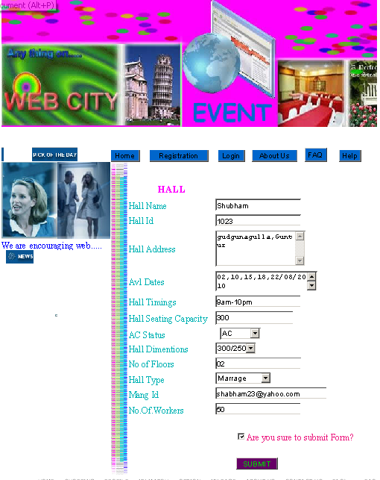

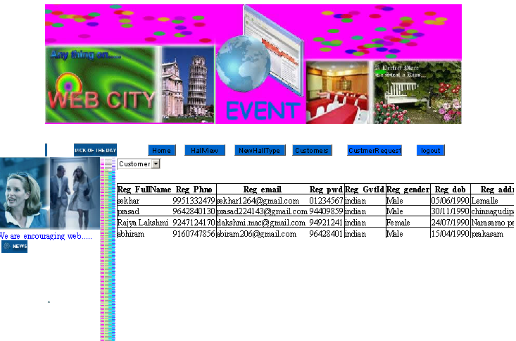
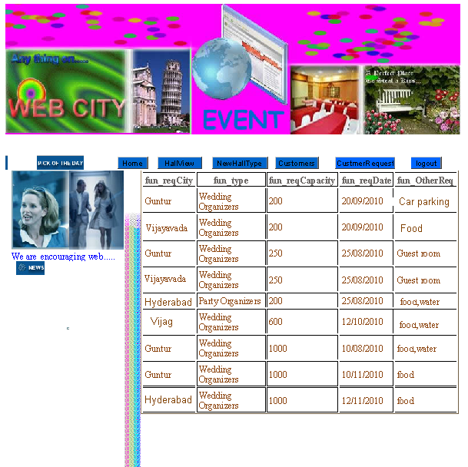

8.CONCLUSION

“E-event Management System” Filling the gap between User and Owner of event Organization.

9. BIBLIOGRAPHY

1. JAMES S.N, “System Analysis and Designing” .

2. PRESSMAN , “Software Engineering”

3. C.J.DATE, KORTH , “ Database Management Systems”.

4. “Mastering Visual Basic” , Technomedia Publications.

5. STEVEN HOLZNER , “C#.NET in 21 days”.

6. TATA MCGRAW HILL , “C#.NET Complete Reference”.

WEB REFRENCE:

- www.google.com
- www.Tellar.com

